Template Final Exam

|  |  |  |
| --- | --- | --- |
| # | Full Name | Group |
|  | Nurmashev Arlan | CS-2107S |
|  |  |  |
|  |  |  |
|  |  |  |

|  |
| --- |
| Link to the repository:  https://github.com/Argoxan/modulevar |

Step-by-step task completion:

Task 1:

Add a new user to the system

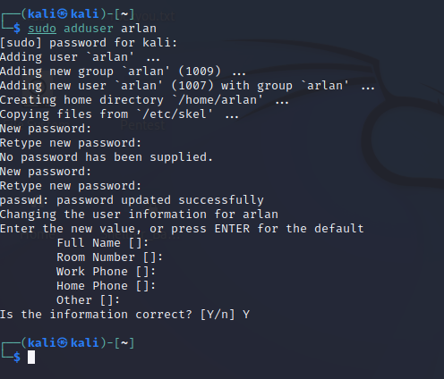

Log in as root

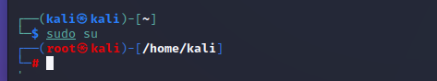

Add a user named student to the system



After entering the passwd student command

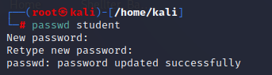

Enter the whoami command

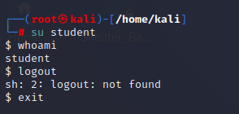

Task 2:

"Direct" IP connection (one of googles ip address)

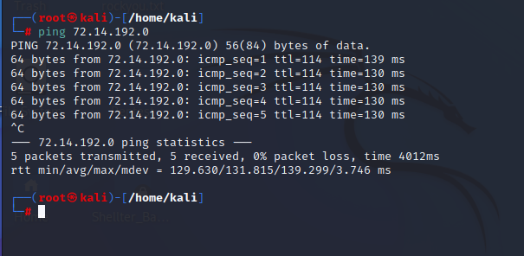

Proxy

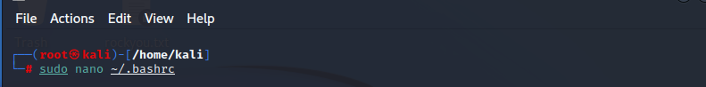

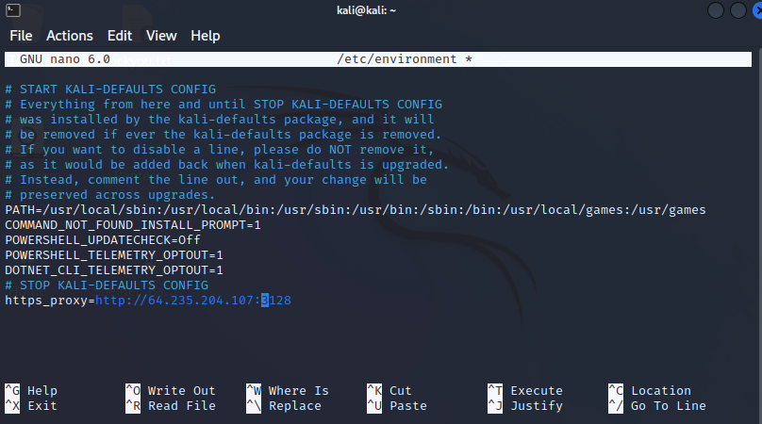

NAT

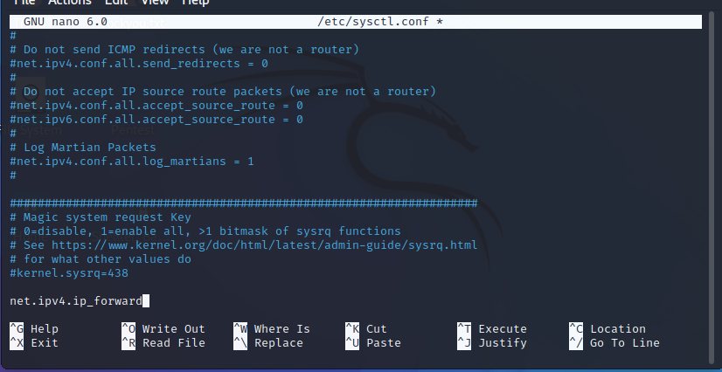



Task 3:

**On kali it didn’t work, so I changed to Ubuntu from Cisco**

I am going to test out a module that stores a variable and allows it to be changed with sysfd.h

Created a new dir and inserted a module



#**include** <linux/fs.h>

#**include** <linux/init.h>

#**include** <linux/kobject.h>

#**include** <linux/module.h>

#**include** <linux/string.h>

#**include** <linux/sysfs.h>

**static** **struct** **kobject** \***mymodule**;

/* Переменная, которую нужно будет изменять. */

**static** **int** myvariable = 0;

**static** **ssize_t** **myvariable_show**(struct kobject *kobj,

struct kobj_attribute *attr, **char** *buf)

{

**return** sprintf(buf, "%d\n", myvariable);

}

**static** **ssize_t** **myvariable_store**(struct kobject *kobj,

struct kobj_attribute *attr, **char** *buf,

**size_t** count)

{

sscanf(buf, "%du", &myvariable);

**return** count;

}

**static** **struct** **kobj_attribute** **myvariable_attribute** =

__ATTR(myvariable, 0660, myvariable_show, (**void** *)myvariable_store);

**static** **int** __init **mymodule_init**(**void**)

{

**int** error = 0;

pr_info("mymodule: initialised\n");

mymodule = kobject_create_and_add("mymodule", kernel_kobj);

**if** (!mymodule)

**return** -ENOMEM;

error = sysfs_create_file(mymodule, &myvariable_attribute.attr);

**if** (error) {

pr_info("failed to create the myvariable file "

"in /sys/kernel/mymodule\n");

}

**return** error;

}

**static** **void** __exit **mymodule_exit**(**void**)

{

pr_info("mymodule: Exit success\n");

kobject_put(mymodule);

}

module_init(mymodule_init);

module_exit(mymodule_exit);

MODULE_LICENSE("GPL");

Then a create my Makefile



obj-m += hello-sysfs.o

all:

make -C /lib/modules/$(shell uname -r)/build M=$(PWD) modules

clean:

make -C /lib/modules/$(shell uname -r)/build M=$(PWD) clean

Next I executed make

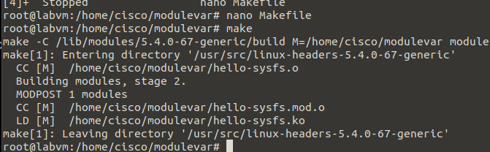

We can see new generated files

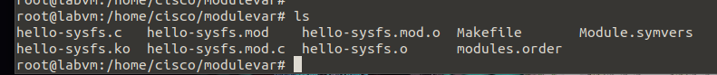

Execute ko file and check if its working

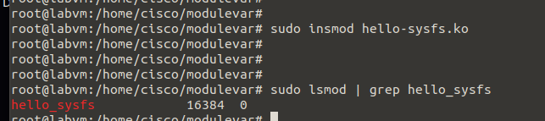

Myvaribale is equal to 0 right now



Lets change that and it works

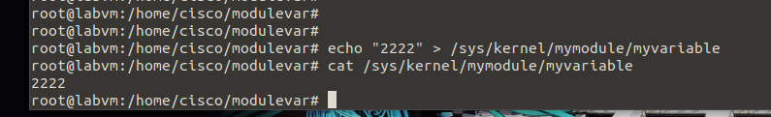

And now lets remove the module

